MINI PROJECT

CLINIC MANAGEMENT SYSTEM

Group Members:

1. Rushank Shah – 60003180043
2. Rutwik Shah – 60003180044

PROBLEM STATEMENT:
(A copy of the requirements of the user is attached to the following document.)

GUI SNAPSHOTS:

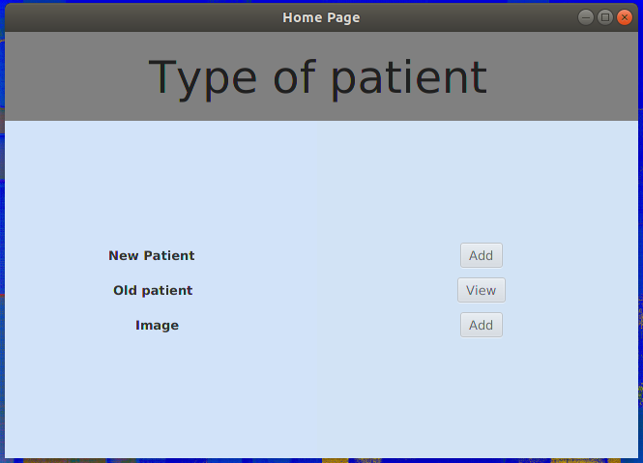
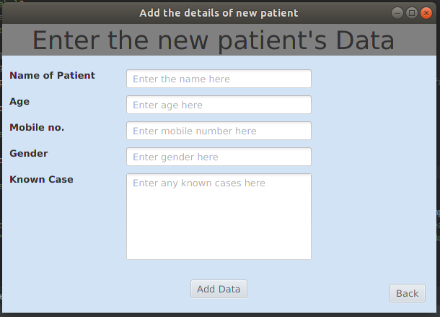

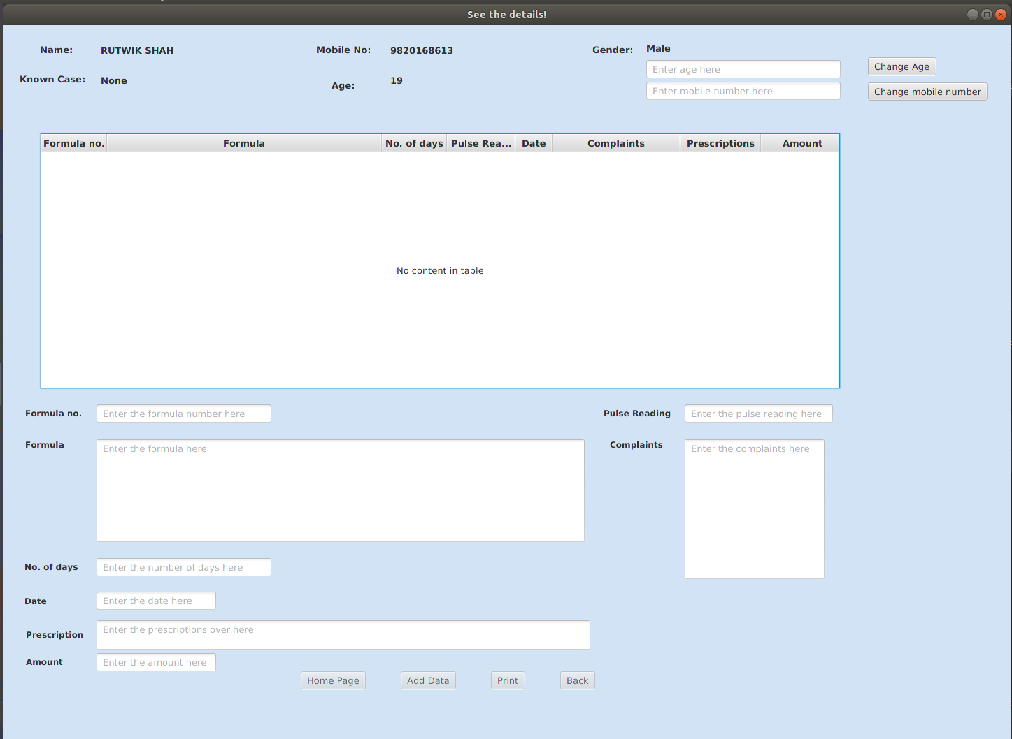

Code for event Handling:

This function handles the events for adding an image to the button.

public void fullImageButtonPushed11(ActionEvent e) throws IOException {
if (count == 10) {
ImageViewController.bufferedImage = SwingFXUtils.fromFXImage(patientImage5.getImage(), null);
Parent scene2Parent = FXMLLoader.load(getClass().getResource("ImageView.fxml"));
Scene newPatientScene = new Scene(scene2Parent);
Stage window = (Stage) ((Node) e.getSource()).getScene().getWindow();
window.setScene(newPatientScene);
window.setTitle("See the whole image");
window.setFullScreen(false);
window.setFullScreenExitHint("");
window.show();
} else if (count < 10) {
errorLabel.setText("Enter the previous images");
} else {
Stage stage = (Stage) ((Node) e.getSource()).getScene().getWindow();
fileChooser = new FileChooser();
fileChooser.setTitle("Choose the new Image");

String userDirectoryString = System.getProperty("user.home");
File userDirectory = new File(userDirectoryString);
if (!userDirectory.canRead())
userDirectory = new File("C:/");

fileChooser.setInitialDirectory(userDirectory);
this.filePath = fileChooser.showOpenDialog(stage);

try {
BufferedImage bufferedImage = ImageIO.read(filePath);
Image image = SwingFXUtils.toFXImage(bufferedImage, null);
patientImage11.setImage(image);
} catch (IOException error) {
System.err.println(error.getMessage());
}
}
}

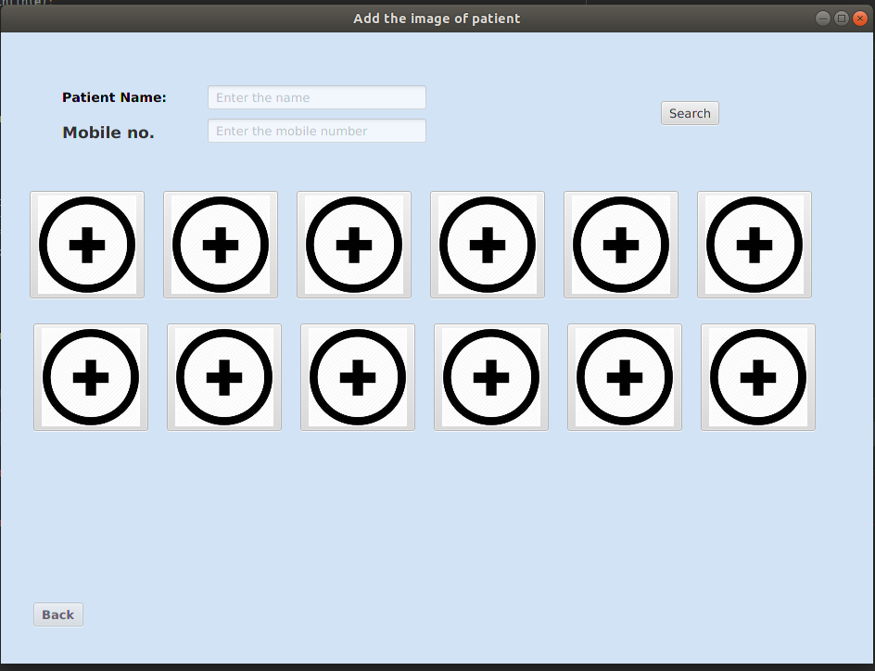

Code for connection with the database:

try {

Class.forName("com.mysql.jdbc.Driver");
Connection con = DriverManager.getConnection("jdbc:mysql://localhost:3306/Clinic_Management", "root", "password");
Statement stmt = con.createStatement();
ResultSet rs = stmt.executeQuery("select photo from photo where patient_id = " + patientID);
while (rs.next()) {
i++;
Blob b = rs.getBlob(1);
byte barr[] = b.getBytes(1, (int) b.length());

FileOutputStream fout = new FileOutputStream(path);
fout.write(barr);
fout.close();
}
} catch (Exception e) {
System.out.println(e);
}

SnapShots of DB tables:

